Example No 1:

Input:

using System;

namespace Abdullah_Sadiq_Cp_Lab_6

{

class Program

{

static void Main(string[] args)

{

for (int i = 0; i <= 10; i++)

{ Console.Write(i + ","); }

}

}

}

Output:

Example no 2

Input:

using System;

namespace Abdullah_Sadiq_Cp_Lab_6

{

class Program

{

static void Main(string[] args)

{

for (int i = 1, sum = 1; i <= 128; i = i*2, sum *=i)

{

Console.WriteLine("i = {0}, sum = {1}", i, sum);

}

}

}

}

Output:

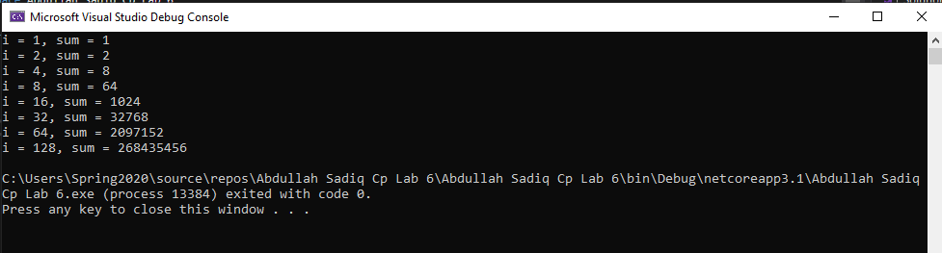

Example no 3

Input:

using System;

namespace Abdullah_Sadiq_Cp_Lab_6

{

class Program

{

static void Main(string[] args)

{

for (int i = 1; i <= 10; i++)

{

Console.WriteLine("2x{0} ={1}", i,i * 2);

}

}

}

}

Output:

Example No 04

Input:

using System;

namespace Abdullah_Sadiq_Cp_Lab_6

{

class Program

{

static void Main(string[] args)

{

for (int small = 1, large = 10; small<large; small++,large--)

{

Console.WriteLine(small + " " + large );

}

}

}

}

Output:

Example No 05

Input:

using System;

namespace Abdullah_Sadiq_Cp_Lab_6

{

class Program

{

static void Main(string[] args)

{

for (int i = 0; i < 3; i++)

{

for (int j = 0; j < 3; j++)

{

Console.Write("*" + " ");

}

Console.WriteLine("");

}

}

}

}

Output:

Task No 01: Cube series without using power math function. (Use For loop)

Input:

using System;

namespace Abdullah_Sadiq_CP_Home_Tasks

{

class Program

{

static void Main(string[] args)

{

for (int i = 1; i <=10; i++)

{

Console.WriteLine("The Cube of {0} is {1}", i, i*i*i);

}

}

}

}

Output:

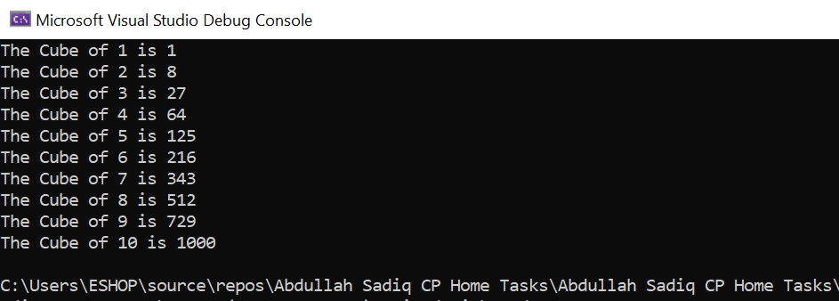

Task No 02: Square Series without using power math function (use For loop).

Input:

using System;

namespace Abdullah_Sadiq_CP_Home_Tasks

{

class Program

{

static void Main(string[] args)

{

for (int i = 1; i <=10; i++)

{

Console.WriteLine("The Square of {0} is: {1}", i, i*i);

}

}

}

}

Output:

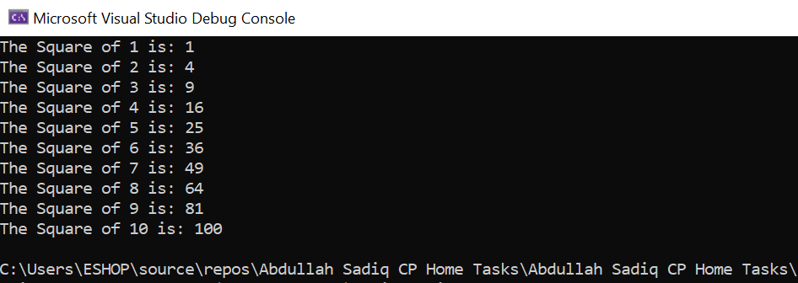

Task No 03: Repeatedly print the value of the variable x Value, decreasing it by 0.5 each time, as long as the x value remains Positive.

Input:

using System;

namespace Abdullah_Sadiq_CP_Home_Tasks

{

class Program

{

static void Main(string[] args)

{

double num;

Console.Write("Enter the Value of x: ");

num = Convert.ToDouble(Console.ReadLine());

for (double i = num; i >0;)

{

Console.WriteLine("{0,-5:0.0}- 0.5 = {1,-5:0.0}", i, i -= 0.5);

}

}

}

}

Output:

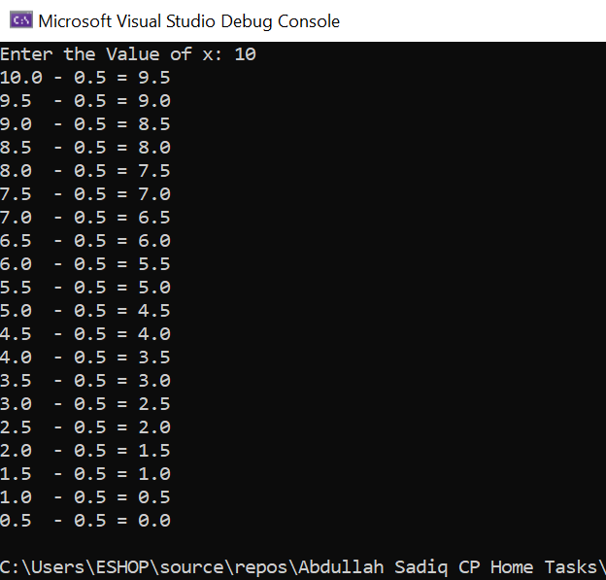

Task No 04: Print the square roots of the first 25 odd positive integers.

Input:

using System;

namespace Abdullah_Sadiq_CP_Home_Tasks

{

class Program

{

static void Main(string[] args)

{

Console.WriteLine("Square root of first 25 odd positive integers");

for (int i = 1; i < 50; i++)

{

Console.WriteLine("The Square Root of {0,-2:0} is: {1,-5:0.0}", i, Math.Sqrt(i));

i += 1;

}

}

}

}

Output:

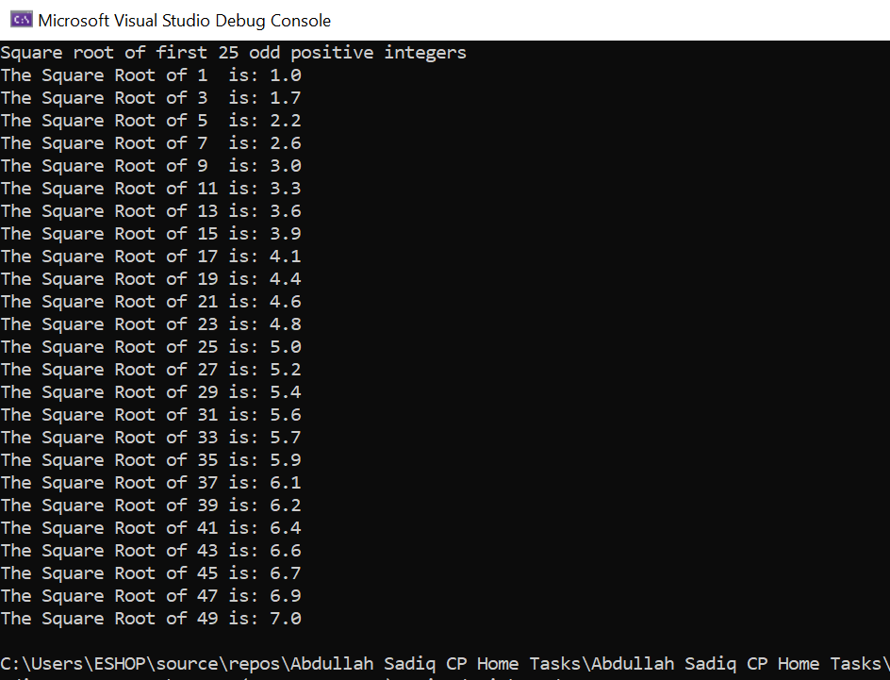

Task No 05: Make a game in C#, in which give 5 tries to the user to guess the value of the number.

Input:

using System;

namespace Abdullah_Sadiq_CP_Home_Tasks

{

class Program

{

static void Main(string[] args)

{

int secret = 69, value, guess = 1;

Console.WriteLine("\t-Secret Number Game-");

for (int i = 0; i < 5; guess++, i++)

{

Console.WriteLine("\nEnter a Secret Number:");

value = int.Parse(Console.ReadLine());

if (value == secret)

{

Console.WriteLine("\nCorrect.\nYou took {0} try to guess a Secret Number.", guess);

break;

}

else

{

Console.WriteLine("\nWrong Answer!\nTry Again.");

}

}

}

}

}

Output:

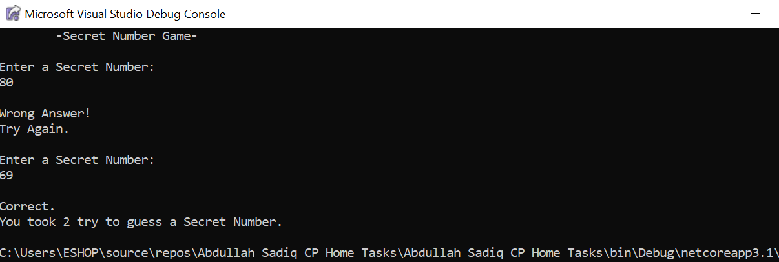

Task No 06: Generate Stars using 2 for loops

Input:

using System;

namespace Abdullah_Sadiq_CP_Home_Tasks

{

class Program

{

static void Main(string[] args)

{

for (int i = 0; i < 4; i++)

{

for (int j = 0; j <= i; j++)

{

Console.Write("* ");

}

Console.WriteLine("");

}

}

}

}

Output:

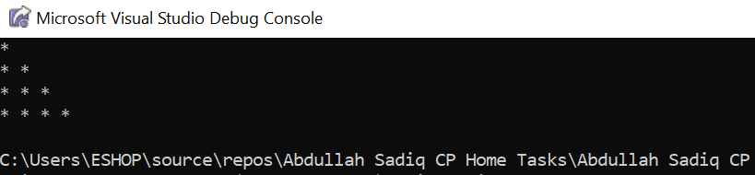

Task No 07: Write a program that reads from the console a positive integer number N (N < 20) and prints a matrix of numbers as N = 3 N = 4.

Input:

using System;

namespace Abdullah_Sadiq_CP_Home_Tasks

{

class Program

{

static void Main(string[] args)

{

Console.WriteLine("Please Enter a Number (Below 20):");

int num = Convert.ToInt32(Console.ReadLine());

if (num <= 20)

{

for (int i = 1; i <= num; i++)

{

for (int j = 0; j < num; j++)

{

Console.Write("{0} ", i + j);

}

Console.WriteLine(" ");

}

}

else

{

Console.WriteLine("Invalid Input!");

}

}

}

}

Output:

